**Manual run for one table by using EMR service:**

* Clone antm_cii_all bitbucket into local and modify code as per your requirement in eclipse or IntelliJ and then run maven build with success status as mentioned below screenshot

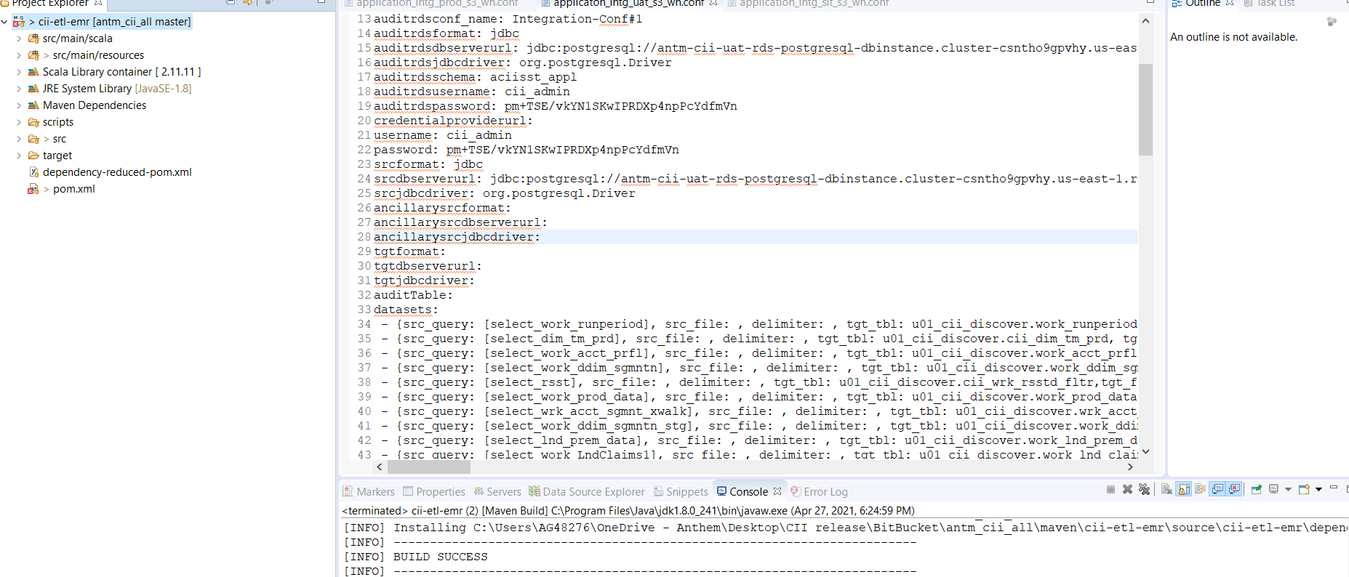

* Go to services -> S3 bucket -> antm-cii-sit-codez-nogbd-nophi-useast1

Upload new maven build jar file into s3 bucket codez location

For example: s3://antm-cii-sit-codez-nogbd-nophi-useast1/etl/ciiu01/jar/cii-etl-emr-1.0.jar

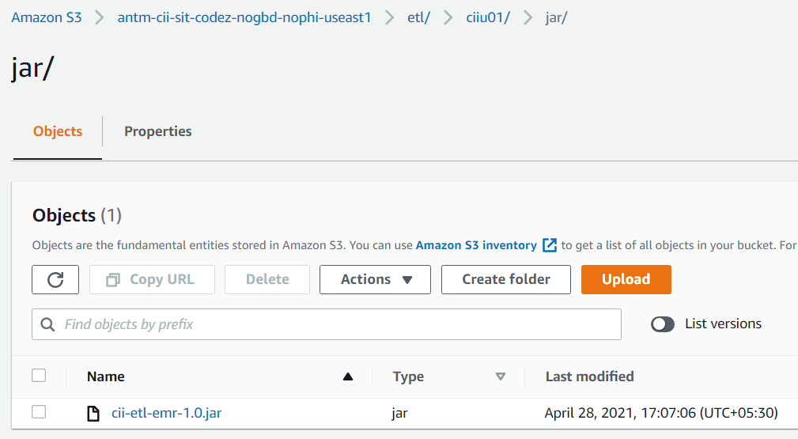

**Note:** Please create your own dev folder in s3 to use the jar independently like ciiu01

* Go to services -> StepFunction -> search with “**ANTM-EDL-sit-Sfn-InvokeEMRAsyn**c”

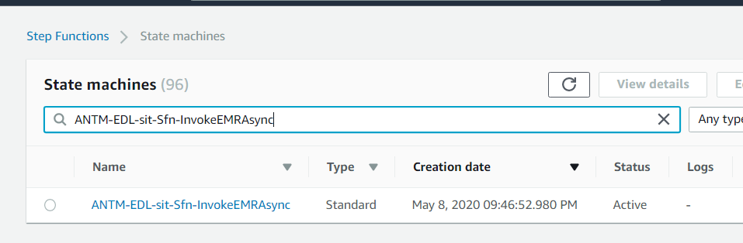

* Click on “start execution” and pass the spark submit parameters over the Stepfunction input based on your requirement

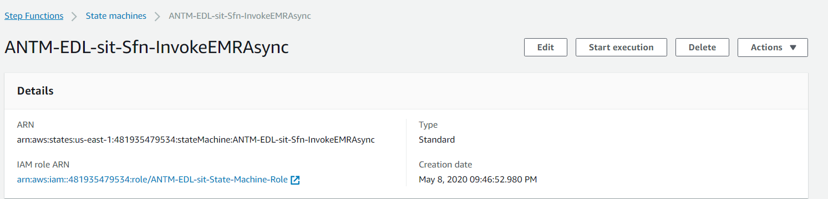

Below is the sample StepFunction input:



* The above Stepfunction will create new EMR cluster and submit the job as shown screenshot below

Go to services -> EMR -> click on EMR service which have entered in stepfunction input

Once the EMR is went to waiting or running state then we can see current job status in STEPS option

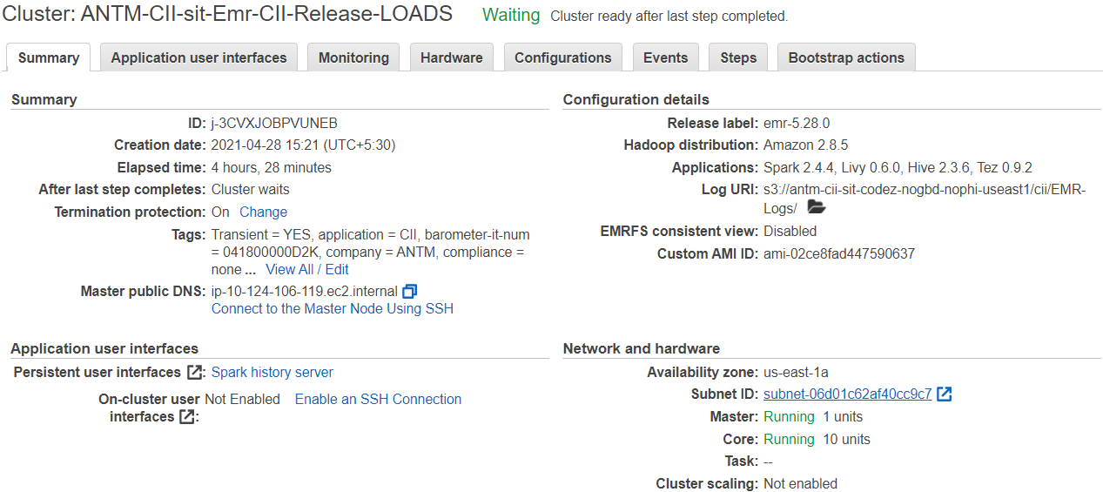

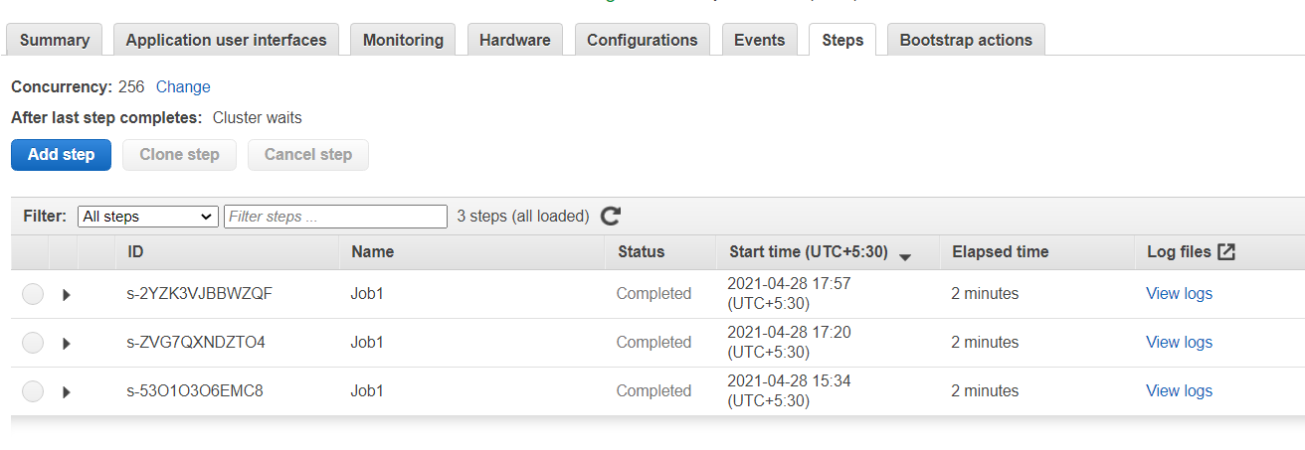

* Once the Job is completed, EMR should terminate because in the input we have updated "terminateoption": "YES"